EpiPen Affordability: The Cost of Saving Lives
By: Anneliese Lapides

According to the Wall Street Journal, about 3.6 million people were prescribed EpiPens in America in 2015¹ in order to combat allergic reactions to stings and foods such as peanuts. EpiPens contain the hormone epinephrine, a manmade version of adrenaline. Epinephrine acts against allergic reactions when injected into the body by constricting blood vessels, or making them smaller². This constricting of the blood vessels increases blood pressure and relaxes the muscles of the lungs in order to restore breathing. This also increases heart rate and reduces swelling caused by the allergic reaction. Because EpiPens provide crucial medication to so many people of all ages across the country with harmful allergies, it is important that they be affordable. The recent controversy surrounding EpiPens is the expensive cost. Mylan, one of the largest international pharmaceutical companies, has increased the price of EpiPens over the past decade due to upgrades in the model of the medicine-delivering contraption. However, some argue that the “new” EpiPen is hardly so different from the EpiPen that exponentially less expensive nine years ago. While pharmaceutical company pricing is not a new issue, the controversy over the price of the EpiPen is making recent headlines due to its importance in the lives of so many Americans. This demographic includes children, who constantly face the risk of encountering their allergen in their everyday lives.
The CEO of Mylan, Heather Bresch, must defend the company’s reason for the increase in the price of EpiPen in front of Congress. In a New York Times interview, her rebuttal to the controversy over the high cost of the EpiPen was “‘I am running a business.’”³ How much has Mylan increased the price of the EpiPen? In 2007, the device cost around $100. Now, the device costs over $600; this is a 400 percent increase in price over the past nine years⁴. The medicine inside of the contraption does have an expiration date, which requires up to an additional $500 to refill⁴.
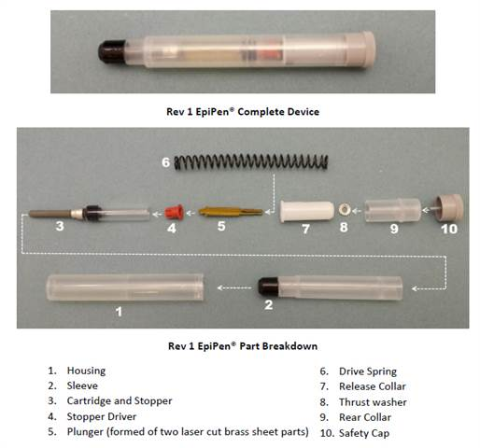
Mylan has connected the large price increase of the EpiPen to upgrades made in the structure of the device. Two versions of the device were compared by PA Consulting Group, a technology consulting firm in the UK⁵. The EpiPen pictured below is one with a 2009 expiration date. Photo: nbcnew.com⁵.

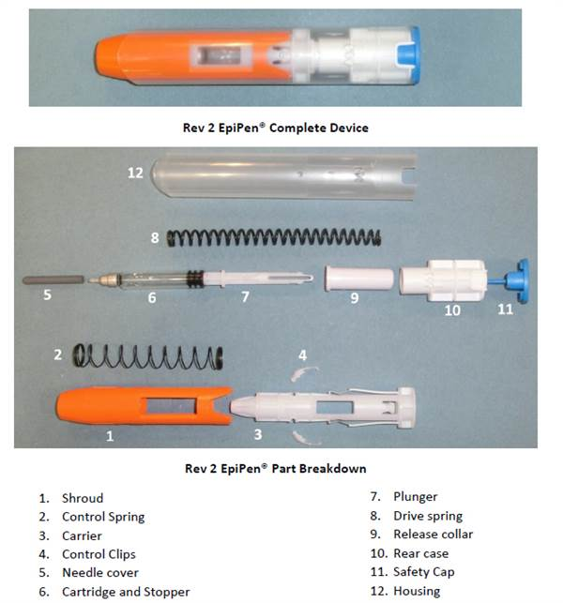
The second EpiPen, pictured below, has a 2015 expiration date and replaces some pieces while also including new, additional pieces. Photo: nbcnews.com⁵.

In conclusion of their investigation, the head of the medical technology branch of PA Consulting Group stated: “‘It’s the same core device that’s been in use for some time.’”⁵ This comparison of the two models, the former over $500 less than the latter, is an example of the overall function and practicality of the device is the same in both devices.
So we ask ourselves, if both models perform the same function in the same general manner, then why should the new model be so much more expensive? For families with children who have allergies, it is important that they are able to afford EpiPens in order to provide proper medical care if a life-threatening allergic reaction were to occur. While EpiPens are covered by most insurance companies, some Americans do not have insurance or they have providers who do not cover the medicine-delivering device or epinephrine refills. Affordability of medicine is already a greatly argued problem in our country, and EpiPens are no exception. It is incredibly likely that most people know at least one person who needs an EpiPen. The necessity of this product in so many peoples’ lives should be taken into consideration when discussing its price in order for this medicine to reach the people who need it and, in turn, save lives.

______________________________________________________________________________
¹Tunney, K. How many people use EpiPens in America? Mylan’s price increase is taking advantage of its users
²Mylan Specialty L.P. What is epinephrine?
³Abramson, A. Mylan CEO to defend EpiPen price increase before Congress
⁴Ho, C. CEO at center of EpiPen price hike controversy is Sen. Joe Manchin’s daughter
⁵Popken, B. Mylan’s upgraded EpiPen torn apart by experts
Literature Cited

Abramson, Alana. "Mylan CEO to Defend EpiPen Price Increase Before Congress." ABC News, ABC News Internet Ventures, 20 Sept. 2016, abcnews.go.com/Politics/mylan-ceo-defend-epipen-price-increase-congress/story?id=42232002. Accessed 2 Oct. 2016.

Ho, Catherine. "Congress CEO at center of EpiPen price hike controversy is Sen. Joe Manchin’s daughter." The Washington Post, 24 Aug. 2016, www.washingtonpost.com/news/powerpost/wp/2016/08/24/ceo-at-center-of-epipen-price-hike-controversy-is-sen-joe-manchins-daughter/. Accessed 2 Oct. 2016.

Popken, Ben. "Mylan's Upgraded EpiPen Torn Apart by Experts." NBC News, nbcnews.com, 30 Sept. 2016, www.nbcnews.com/business/consumer/mylan-says-it-upgraded-epipen-2009-so-experts-looked-inside-n652651. Accessed 2 Oct. 2016.

Tunney, Kelly. "How Many People Use EpiPens in America? Mylan's Price Increase Is Taking Advantage of Its Users." Bustle, 26 Aug. 2016, www.bustle.com/articles/180800-how-many-people-use-epipens-in-america-mylans-price-increase-is-taking-advantage-of-its-users. Accessed 2 Oct. 2016.

"What Is Epinephrine?" EpiPen, Mylan Specialty L.P., 2016, www.epipen.com/en/about-epipen/what-is-epinephrine. Accessed 2 Oct. 2016.

