Aybuke Akyarar
21 February 2017
Air Pollution May Raise Risk of Type 2 Diabetes
A study of obese Hispanic children suggests that smog might boost chances of developing diabetes. So what really is diabetes? Diabetes is a disease in which your blood glucose, or blood sugar, levels are too high. Glucose comes from the foods you eat. Insulin is a hormone that helps the glucose gets into your cells to give them energy (WebMD). With Type 1 diabetes, your body does not make insulin. With Type 2 diabetes, the more common type, your body does not make or use insulin well. Without enough insulin, the glucose stays in your blood (WebMD). "Poor air quality appears to be a catalyst for obesity and diabetes in children, but the conditions probably are forged via different pathways," says Michael Goran who is the co-director of the University of Southern California's Diabetes and Obesity Research Institute (Preidt).
For the study, researchers followed 314 overweight or obese Hispanic children in Los Angeles County. The children were between 8 and 15 years old when the study started and none of them had diabetes (Preidt). By the time children who lived in areas with high levels of air pollution turned 18, their insulin-producing pancreatic cells -- called beta cells -- were 13 percent less efficient than normal. The study authors noted in the news release that, “When beta cells stop working as they should, the risk of developing type 2 diabetes rises” (Preidt). Diabetes has quadrupled in the United States in the past four decades, according to the U.S. Centers for Disease Control and Prevention. If nothing changes, one-third of Americans could have diabetes by 2050, putting them at risk for complications such as blindness, kidney failure, limb amputation or early death, the researchers said. A lead author of the story acknowledges that it is nearly impossible to avoid pollution and the best we can do is be aware of the factors that contribute to it and try to avoid them as much as possible (Preidt).
Air pollution is a leading cause of insulin resistance and incidence of type 2 diabetes mellitus (Preidt). The association between air pollution and diabetes is stronger for traffic associated pollutants, gaseous, nitrogen dioxide, tobacco smoke and particulate matter (ADA). Type 2 diabetes and obesity are spreading at an alarming rate, and factors that may contribute to the spread are the subject of many recent studies (ADA). Researchers have long thought that certain environmental factors could contribute to the development of type 2 diabetes and obesity. Among these factors are man-made chemicals called persistent organic pollutants (POPs). Humans are exposed to POPs by eating contaminated food, mainly meat, fish, and dairy products (ADA). The researchers examined 151 adult obese subjects with or without known type 2 diabetes and compared them with 44 normal-weight volunteers (ADA).
They found higher levels of POPs in participants who were obese, particularly in those with high fat mass—the type of adiposity that is strongly linked to heart disease and type 2 diabetes. Additionally, they detected a connection between high blood glucose levels and total body levels of POPs (ADA). This link was significant, even when taking into account known risk factors, such as body mass index, age, family history of diabetes, and physical activity level. The higher levels of POPs in obese participants could be the result of simply having more body fat available to absorb POPs (ADA). In conclusion, it is not known whether other factors, such as diet, birth of a child, or breast-feeding, could have affected the levels of POPs in participants. Also, there are other chemicals that have been linked to diabetes and obesity that were not studied in these participants (ADA).

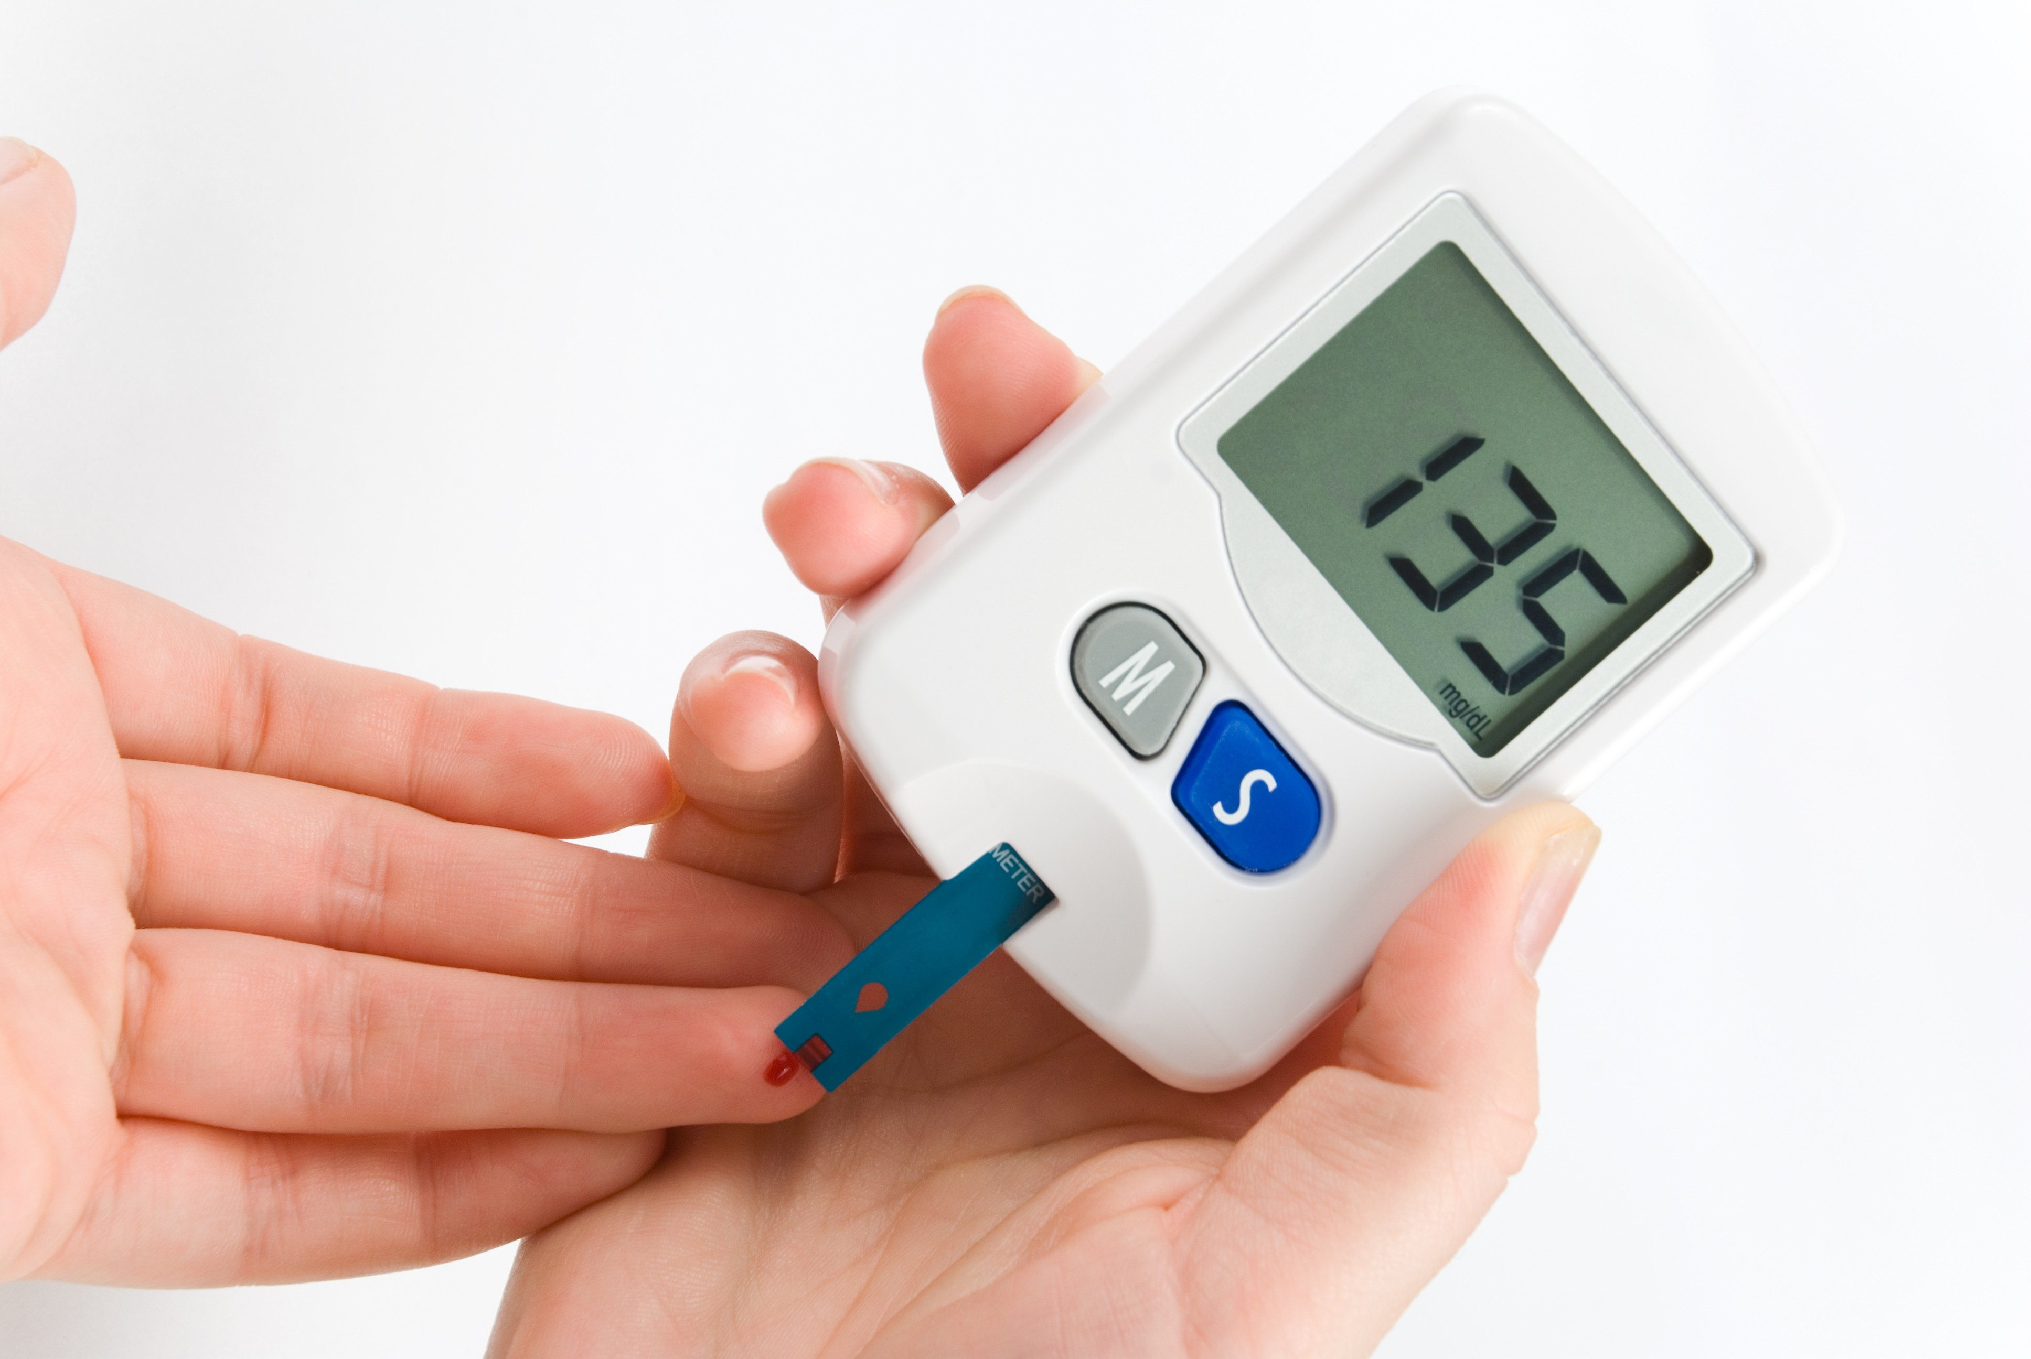

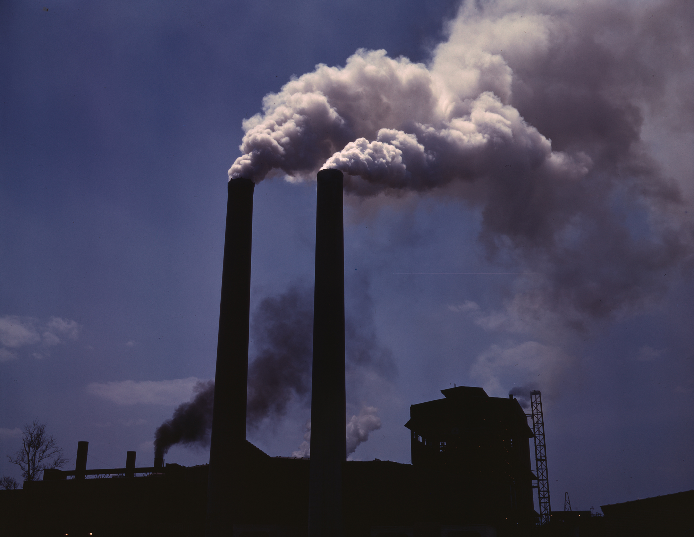

Works Cited
"Can Pollution Cause Diabetes and Obesity?" American Diabetes Association. N.p., n.d. Web. 20
Feb. 2017.
Preidt, Robert. "Air Pollution May Raise Risk of Type 2 Diabetes." MedlinePlus Health News.
HealthDay, n.d. Web. 20 Feb. 2017.
"WebMD Diabetes Center: Types, Causes, Symptoms, Tests, and Treatments." WebMD.
WebMD, n.d. Web. 20 Feb. 2017.
Digital Images:
Glucose Test: http://pregnancywellnesstips.com/wp-content/uploads/2016/05/diabetes-cure.jpg
Pollution: https://upload.wikimedia.org/wikipedia/commons/a/aa/AlfedPalmersmokestacks.jpg

